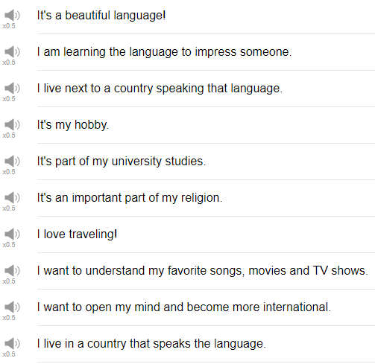

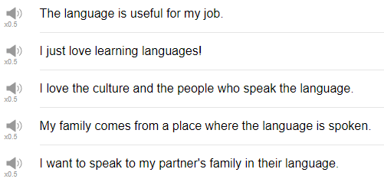

|  |
| --- |
| Hi everybody! Welcome back to Top Words my name is Alisha, and today we're gonna be talking about 10 Reasons to Learn English. So these are some ways that you can respond to the question "why are you learning English?" Let's go! |
| 1. I love the culture and the people who speak the language. |
| Oh, why, thank you! Maybe choose or know which culture or which kind of English you're the most interested in. |
| 2. I love traveling. |
| You are the kind of person who wants to go too many different countries and you want to be able to speak to the people in those countries, presumably english-speaking countries, you can say I love traveling. |
| 3. I want to open my mind and become more international. |
| If you live in a country where, you know, the culture there's maybe just your home country's language, and just your home country's culture, and there's not a lot of mixing, as there is, for example, in America. Maybe use this phrase with your co-worker, with your family members to say I want to, maybe, change my mindset a little bit, i want to explore things beyond this culture, beyond this language. |
| 4. I want to understand my favorite songs, movies, and TV shows. |
| The next reason is I want to understand my favorite songs, movies, and TV shows. This is a really really popular reason for learning another language. I think not just English but if there's a TV show, a movie that you really really like, and you want to understand it and enjoy it on another level, you can try to understand it in the language that the movie is presented. In this case, in English. I think it's a really fun motivation for learning another language. |
| 5. The language is useful for my job. |
| If you're the kind of person or if you have the kind of job that requires you speak to people from other countries, English might be really really useful for you. So you can say the language is useful for my job, or I need English for my work, something like that. |
| 6. I'm learning the language to impress someone. |
| This could have many different meanings, maybe it means you're interested romantically in someone and you want to impress them, maybe that person is a native speaker of English, and you think, oh I want to learn English to impress that guy, or impress that girl. Fine! Great! Honestly that's a really good motivation for learning another language is one thing to be able to speak fluently to that person in that language great, like that being said, i don't know that i would say i'm learning the language to impress someone. |
| 7. I live next to a country speaking that language. |
| Maybe you share borders with an English-speaking country learning English could be useful for you, or fun for you Okay! |
| 8. I want to speak to my partner's family in their language. |
| So maybe you and your partner share a common language and you can communicate together, but maybe your partner's family does not have that same common language. you maybe decide i want to learn some of the language, so that i can communicate with my partner's family. That might be a good reason to study! |
| 9. It's part of my university studies. |
| If it's part of your university course, or if you're required to learn a language in your university or high school, other school, you can say it's part of my university studies, or I have to take a language. That's a phrase that we use, a phrase that we use in my college, i think, i have to take a language. Don't forget that i have to take a language, or I have to take english for two years, something like that. |
| 10. I just love learning languages. |
| The next expression, very positive! It's just I love learning languages. I just love learning languages, maybe you're the type of person who just really really is interested, and you can say i just love learning languages, i think it's really interesting. That's a cool reason. |
| So those are 10 reasons that you can give if someone asks you why you're studying English. I hope that you have a few reasons, it's probably good to have a few reasons, but only one is ok. Thanks very much for watching this episode of Top Words. Please make sure to subscribe to our channel, if you have not already. Thank you, thank you, thank you so much in advance! Thanks for watching this episode, and we'll see you again next time! Bye! |